J100

JERZEES

6.1-Ounce Jersey Knit Sport Shirt

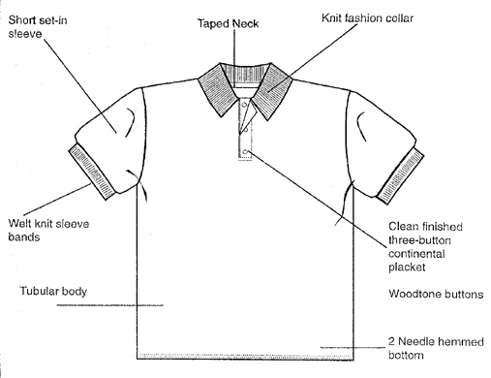

Finished Garment Measurements

Size | S | M | L | XL | 2XL | 3XL
Width 1” under armhole | 18 | 20 | 22 | 24 | 26 | 27
Length from shoulder | 28 | 29 | 30 | 31 | 32 | 33
Sleeve Length from CB | 18 ½ | 19 ½ | 20 ½ | 21 ½ | 22 ½ | 23 ½
Shoulder Width | 17 ¼ | 19 ¼ | 21 ¼ | 23 ¼ | 25 ¼ | 26 ¼

